Table of Contents

* What is Host Unit(HU)?
* Example calculation of Host Units
* Agent based monitoring.
* Davis Data Units(DDU)
* **What Do DDUs Cover?**
* **How Are DDUs Consumed?**
* **DDU Weight**
* **Agentless Monitoring(Remote Unix monitoring, SNMP and DB/MW)**
* **Digital Experience Monitoring(DEM)**
* **Example calculation of DEM**
* **Synthetic Monitoring(Ping, HTTP, URL based monitoring)**

**HOST UNITS:(**[Application and Infrastructure Monitoring (Host Units) — Dynatrace Docs](https://docs.dynatrace.com/docs/manage/monitoring-consumption-classic/application-and-infrastructure-monitoring))

**Host Units represent a metric used to measure the licensing and usage of host-based monitoring. It provides a way to quantify the capacity required to monitor hosts, based on their resource consumption. Host Units account for factors like the number of CPUs and the amount of RAM of the host being monitored.**

Larger hosts consume more host units than do smaller-sized hosts. Dynatrace is using the amount of RAM on a monitored server as a measuring stick to determine the size of a host (that is how many host units it comprises).

The cost shown in the table is **daily**, based on **Host Unit (HU)** consumption. Each row represents the daily consumption of Host Units depending on the server's RAM size, with separate calculations for **infrastructure monitoring** and **full-stack monitoring**.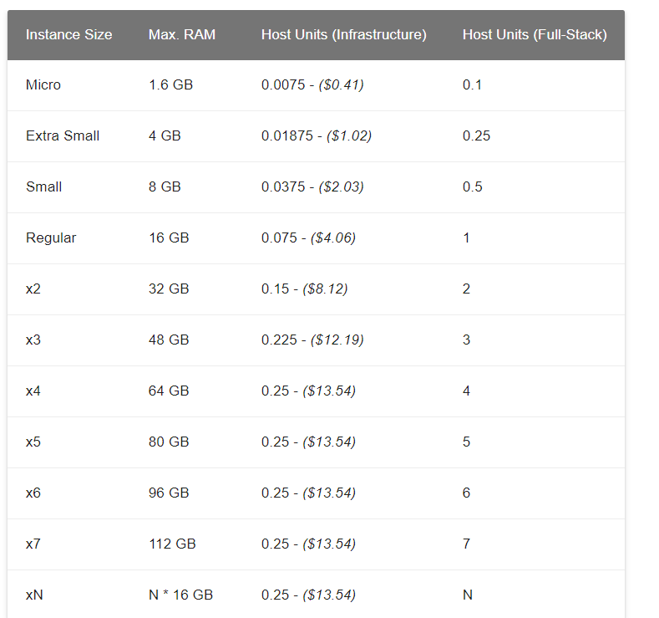

For instance:

* A **Micro instance (1.6 GB)** consumes **0.0075 HUs** per day for infrastructure monitoring, equivalent to **$0.41/day**.
* A **Regular instance (16 GB)** consumes **1 HU** per day for full-stack monitoring, with the associated cost depending on your licensing.
* Total host-unit consumption is calculated based on the sum of all host units of all modes and monitored systems.

**Example: -**

**To calculate the monthly cost of infrastructure monitoring** using **Host Units (HUs)**, we consider the daily HU consumption for infrastructure and multiply it by the number of days in a month (e.g., 30 or 31 days). The daily HU values are listed in the provided table.

**Showing 1000 of 4706 hosts.**

**Some of your important hosts may not be visible. Please refine your filters to see more details and options.**

**Host unit consumption: 464.8 (for 1000 visible hosts) / 1928.825 (for 4706 total hosts)**

**1Host Unit cost is ~$55**

**Monthly Cost for Infrastructure Monitoring (30 Days):**

| **Instance Size** | **Max RAM** | **Daily HU (Infrastructure)** | **Monthly HU (30 Days)** | **Monthly Cost (Infrastructure)** | **Per Unit cost** |
| --- | --- | --- | --- | --- | --- |
| **Micro** | 1.6 GB | 0.0075 | 0.225 | **$12.30** | $0.41 |
| **Extra Small** | 4 GB | 0.01875 | 0.5625 | **$30.60** | $1.02 |
| **Small** | 8 GB | 0.0375 | 1.125 | **$60.90** | $2.03 |
| **Regular** | 16 GB | 0.075 | 2.25 | **$121.80** | $4.06 |
| **x2** | 32 GB | 0.15 | 4.5 | **$243.60** | $8.12 |
| **x3** | 48 GB | 0.225 | 6.75 | **$365.70** | $12.19 |
| **x4 and above** | 64+ GB | 0.25 | 7.5 | **$406.20** | $13.54 |

**Davis Data Units(**[Extending Dynatrace (Davis data units) — Dynatrace Docs](https://docs.dynatrace.com/docs/manage/monitoring-consumption-classic/davis-data-units))

**Davis Data Units (DDUs)** are a flexible and unified consumption-based licensing model in Dynatrace, used for certain capabilities such as **custom metrics, log monitoring, and custom events**.

**What Do DDUs Cover?**

1. **Custom Metrics**:
   * Includes metrics from APIs, integrations, and other sources outside Dynatrace's default monitoring.
   * Examples: External cloud metrics, third-party APIs, or metrics pushed to Dynatrace via integrations.
   * **Cost per Metric**: A single custom metric can consume DDUs based on the data points ingested (e.g., per minute/hour intervals).
2. **Log Monitoring**:
   * Covers the storage, analysis, and querying of logs.
   * Consumption is based on:
     + **Storage volume** (amount of logs ingested).
     + **Retention period** (how long logs are stored).
   * Example: Ingesting 1 GB of log data may consume a certain number of DDUs.
3. **Custom Events for Alerting**:
   * Events triggered by external sources or systems integrated with Dynatrace.
   * Example: An alert from an external service or a custom rule in Dynatrace.

**How Are DDUs Consumed?**

* **Dynamic Consumption**:
  + DDUs are consumed based on the **volume** of data ingested or processed.
  + For example:
    - A custom metric sampled every minute consumes more DDUs than a metric sampled hourly.
    - Logs ingested from multiple sources at high volume will consume DDUs faster.
* **Unified Quota**:
  + All features covered under DDUs draw from a single pool, making it easier to track overall usage.

**DDU Weight**

Each Dynatrace-supported technology offers multiple “built-in” metrics. Built-in metrics are automatically detected and monitored. Davis Data Units extend the value of Dynatrace’s built-in monitoring capabilities by enabling customers to integrate with third-party data sources, calculate custom metrics, and other use cases. These DDUs may be turned on at the DXC election. Davis Data Units (DDUs) may be consumed as shown in the Dynatrace Davis Data Units (DDU) Weighting Table below.

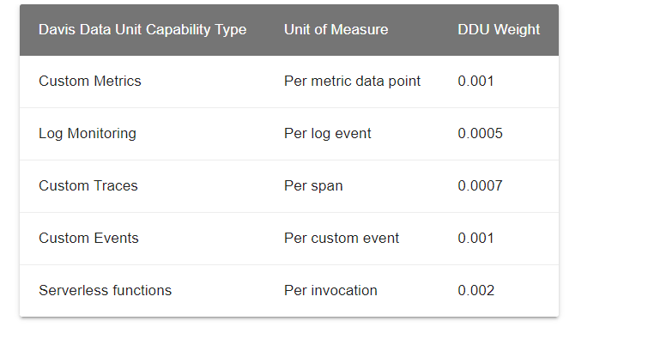

**1. Custom Metrics**

* **What it is**: Custom metrics in Dynatrace are time-series data points that track specific measurements, such as CPU utilization, memory usage, or application performance over time
* **Consumption**:
  + Each metric sampled once per minute consumes **525.6 DDUs per year**.
  + **Formula**:  
    **Total DDUs per year=**1data point/min×60min/hour×24hours/day×365days/year×0.001DDU weight=525.6DDUs/year.
  + A single custom metric sampled once per minute consumes **525.6 DDUs per year**.

**2. Log Monitoring**

* **What it is**: Consumes DDUs based on the number of log events ingested.
* **Consumption**:
  + **1 log event = 0.0005 DDUs**.
  + Example: If you ingest **60 Million log events per month**:
  + **60,000,000×0.0005=30,000DDUs/month**
  + Annual consumption: **30,000×12=360,000DDUs/year.**

**3. Custom Traces**

* **What it is**: Tracks spans (individual operations) within traces, such as API calls.
* **Consumption**:
  + **1 span = 0.0007 DDUs**.
  + Example: If an API generates **1 Million calls per month**, with **10 spans per call**:
  + **1,000,000×10×0.0007=7,000DDUs/month**
  + Annual consumption:**7,000×12=84,000DDUs/year.**

**4.Custom Events:**

* **What it is**: Includes events like Kubernetes, external, or log-based events.
* **Consumption**:
  + **1 event = 0.001 DDUs**.
  + Example: If you ingest **1 Million custom events per month**
  + **1,000,000×0.001=1,000DDUs/month**
  + Annual consumption:**1,000×12=12,000DDUs/year.**

**5. Serverless Functions**

* **What it is**: Tracks monitored invocations of serverless functions.
* **Consumption**:
  + **1 function invocation = 0.002 DDUs**.
  + Example: If you have **1 Million function invocations per month**:
  + **1,000,000×0.002=2,000DDUs/month**
  + Annual consumption:**2,000×12=24,000DDUs/year.**

**Digital Experience Monitoring(**[Digital Experience Monitoring (DEM units) — Dynatrace Docs](https://docs.dynatrace.com/docs/manage/monitoring-consumption-classic/digital-experience-monitoring-units))

**DEM Units** are used for various monitoring features, including Synthetic Ping Monitoring, Dynatrace Synthetic Monitoring, Real User Monitoring (RUM), and Session Replay. These features are billed based on **Digital Experience Monitoring (DEM) units**. The cost factors include the number of devices being pinged and the frequency of pings. The following estimated costs are currently being validated but can serve as a reference:

### ****DEM Consumption for Synthetic ping Monitoring****:

* **5-minute ping frequency** = 876 DEM units per month
* **1 DEM unit** = $0.004
* **Monthly cost** = $3.50 USD per month per **CI** (Configuration Item)

### ****DEM Consumption for HTTP Monitoring****:

For **HTTP monitoring** in Dynatrace (part of **Synthetic Monitoring**), the consumption of **DEM units** depends on the following factors:

* **Synthetic request (HTTP monitor)**:  
  **0.1 DEM** per HTTP request executed by the monitor.

#### **Calculation Example**:

For example, if an **HTTP monitor** runs every 15 minutes from **2 locations** for **1 day**, and each execution generates **1 HTTP request**, the **DEM consumption** would be calculated as:

**0.1 DEM per request×4 executions per hour×2 locations×24 hours per day=19.2 DEM units per day**

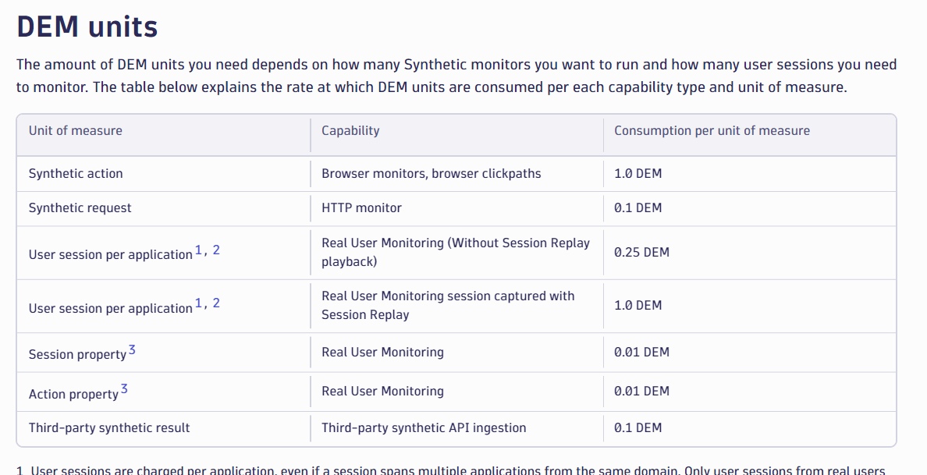

### Dynatrace Host-Unit Metrics and DDU Consumption Overview([DDUs for metrics — Dynatrace Docs](https://docs.dynatrace.com/docs/manage/monitoring-consumption-classic/davis-data-units/metric-cost-calculation))

#### **Key Concepts:**

1. **Host-Included Metrics**:
   * **Full-Stack Monitoring**: Each Host Unit (HU) includes **1,000 metrics per minute**.
   * **Infrastructure Monitoring**: Includes **200 metrics per minute** per Host Unit.
   * Metrics beyond these included limits consume **DDUs (Davis Data Units)**.
2. **Metrics Bound to Hosts**:
   * Metrics are associated with the monitored host or processes on that host.
   * For API-ingested metrics, only those tied to monitored hosts are included in the HU quota.
3. **Excess Metrics**:
   * Metrics exceeding the included count for the host will consume **DDUs**.
   * Metrics unrelated to monitored hosts (e.g., metrics from public APIs) will **always consume DDUs**.

#### **Example Scenarios:**

1. **Host with 16 GiB RAM (1 HU)**:
   * **Metrics Allowed**: 1,000 metrics/min are included.
   * **Actual Usage**:
     + Reports 1,500 metrics via OneAgent.
     + Reports 300 metrics via the API, unrelated to any host.
   * **Excess Metrics**:
     + **500 metrics** from the host consume DDUs.
     + **300 API metrics** consume DDUs directly.
   * **Total Excess**: 800 metrics/min will consume DDUs (800 × 0.001 = 0.8 DDUs/min).
2. **Host with 8 GiB RAM (0.5 HU)**:
   * **Metrics Allowed**: 500 metrics/min are included.
   * **Actual Usage**: Reports 300 metrics.
   * **Excess Metrics**: None, as usage is within the included limits. No DDUs are consumed.
3. **Host with 64 GiB RAM (4 HUs)**:
   * **Metrics Allowed**: 4,000 metrics/min are included.
   * **Actual Usage**: Reports 5,000 metrics.
   * **Excess Metrics**:
     + 1,000 metrics/min exceed the allowance and consume **1 DDU/min** (1,000 × 0.001).
4. **Infrastructure Monitoring**:
   * A host consuming **0.6 HUs** reports **150 metrics/min**.
   * **Metrics Allowed**: 200 metrics/min are included.
   * **Excess Metrics**: None, as usage is within the included allowance.

### Example for Infrastructure Monitoring with Host Units:

#### **Scenario: Host with Infrastructure Monitoring Enabled**

A server with **16 GB of RAM** is monitored in **Infrastructure Monitoring Mode** using OneAgent.

#### **Key Details:**

1. **Host Unit (HU) Consumption**:
   * For **16 GiB RAM**, the host consumes **0.3 HUs**.
2. **Included Metrics**:
   * Each **0.3 HU** includes **200 metrics per minute** without consuming DDUs.
3. **Metrics Reported**:
   * The host reports **1,000 metrics per minute** via OneAgent.
4. **Calculation**:
   * **Metrics Included**: 200 metrics/min (as per 0.3 HUs in Infrastructure Monitoring).
   * **Excess Metrics**: 1,000 - 200 = 800 metrics/min.
   * **DDU Consumption**:
     + 800 excess metrics × 0.001 DDU = **0.8 DDUs per minute**.
     + **Per Day**: 0.8 DDUs/min × 1,440 minutes/day = **1,152 DDUs/day**.
     + **Per Month (30 days)**: 1,152 DDUs/day × 30 days = **34,560 DDUs/month**.

#### **Simplified Summary:**

* **Host RAM**: 16 GiB.
* **Host Units**: 0.3 HU.
* **Metrics Allowed (included)**: 200 metrics/min.
* **Reported Metrics**: 1,000 metrics/min.
* **Excess Metrics**: 800 metrics/min → Consumes **0.8 DDUs/min**.
* **Total DDUs Consumed**:
  + **Per Day**: 1,152 DDUs.
  + **Per Month (30 days)**: 34,560 DDUs.

#### **Reported vs. Consumed DDUs:**

* **Reported DDUs**: Reflects the total metrics before considering host-included allowances.
* **Consumed DDUs**: Actual billable DDUs, excluding the host-included metrics.
* Which metrics consume DDUs?

**Which metrics consume DDUs?**

* All metrics sent via the default OneAgent (for example, host metrics) are included free of charge and do not consume DDUs. Metrics ingested by an extension that are bound to specific hosts (or processes), first consume all available included metrics before consuming any additional DDUs. Metrics ingested by API consume all available included metrics that are bound to specific hosts (not processes) before consuming any additional DDUs.

